SUBNETTING PRACTICAL

Q1. Given a network address of 192.168.10.0/24, divide it into 4 equal subnets and write down the subnet mask, network address, and broadcast address for each subnet.
Ans. To divide 192.168.10.0/24 into 4 equal subnets, borrow 2 host bits:
New subnet mask: /26 = 255.255.255.192
Subnet | Network Address | Broadcast Address | Usable Host Range
1 | 192.168.10.0/26 | 192.168.10.63 | 192.168.10.1-192.168.10.62
2 | 192.168.10.64/26 | 192.168.10.127 | 192.168.10.65 – 192.168.10.126
3 | 192.168.10.128/26 | 192.168.10.191 | 192.168.10.129 – 192.168.10.190
4 | 192.168.10.192/26 | 192.168.10.255 | 192.168.10.193 – 192.168.10.254

Q2. For one of the subnets you created, assign valid IP addresses to 5 devices (such as a router, two laptops, a printer, and a mobile) and list which IP goes to which device. Hint: Make sure not to use the network or broadcast address for any device.
Ans. Let's use Subnet 1: 192.168.10.0/26.
- Network address: 192.168.10.0
- Broadcast address: 192.168.10.63
- Valid host range: 192.168.10.1 – 192.168.10.62
Device | Assigned IP Address
Router | 192.168.10.1
Laptop 1 | 192.168.10.2
Laptop 2 | 192.168.10.3
Printer | 192.168.10.4
Mobile | 192.168.10.5

Subnet Mask: 255.255.255.192
All five addresses are valid because they are between 192.168.10.1 and 192.168.10.62 and do not use the network or broadcast address.

Q3. Draw a simple diagram (hand-drawn or digital) showing your subnet plan: label each subnet, the range of IPs, and where each device is connected.
Ans.
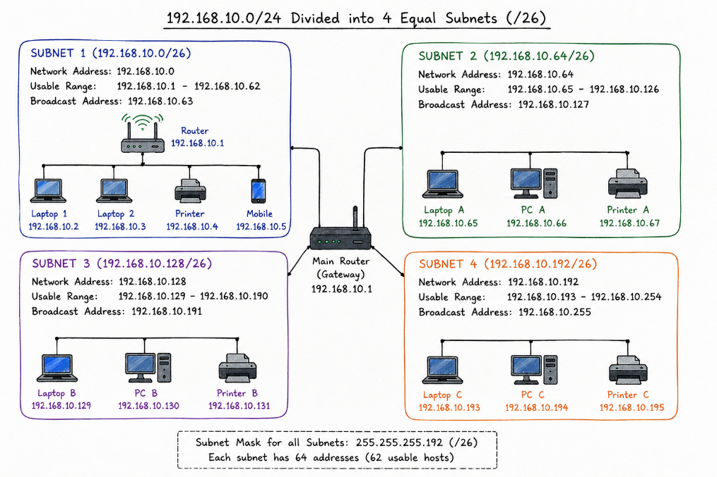
Q4. Document step-by-step how you calculated the subnet mask, number of hosts per subnet, and assigned IP addresses for your plan, as if you are explaining it to a friend who is new to subnetting.
Ans. Step 1: Calculate the Subnet Mask
- Network: 192.168.1.0/24
- Subnet mask: 255.255.255.0
- We need 4 subnets, so we borrow 2 bits.
- New subnet mask: /26 = 255.255.255.192
Step 2: Calculate Hosts per Subnet
- Remaining host bits: 6
- Total addresses: 2⁶ = 64
- Usable hosts: 64 − 2 = 62
- So, each subnet supports 62 usable devices.
Step 3: Assign IP Addresses
For the first subnet:
- Network address: 192.168.1.0
- Router: 192.168.1.1
- Laptop 1: 192.168.1.2
- Laptop 2: 192.168.1.3
- Printer: 192.168.1.4
- Mobile: 192.168.1.5
- Broadcast address: 192.168.1.63
Subnet mask for all devices: 255.255.255.192

